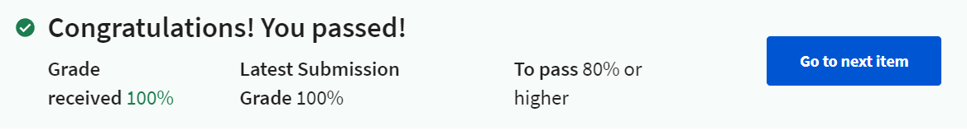

1. Which of the following statements describe key responsibilities of a View?

=>

**To draw themselves.**

**To respond to events directed to them.**

2. Which of the following are properties that can be set on a View?

=>

**Visibility.**

**Position.**

**Opacity (transparency).**

3. (True or False) - An AutoCompleteTextView is a subclass of ViewGroup. Hint: Consult the Android documentation at http://developer.android.com/reference/classes.html

=> **False.**

4. Which of the following statements describe the relationship between and AdapterView and its Adapter?

=>

**Adapters can notify the AdapterView when the Adapter data changes.**

**The Adapter manages a data set for the AdapterView.**

5. Suppose a layout file declares a LinearLayout called LL that contains two child Views, View1 and View2. In the layout file View1 is given an android:layout_weight of 2 and a layout_width of 0dp. View 2 is given an android:layout_weight of 3 and a layout_width of 0dp.

In this example, which of the following statements must be true?

=> **View 2 takes up 3/5 of LL's width.**

6. When a user long clicks on a View that has registered to show a Context Menu, which one of the following methods will be called?

=> **onCreateContextMenu().**

7. Suppose that an application wants to create and display a Dialog. If the application embodies the Dialog in a DialogFragment, which DialogFragment method will it call to make the Dialog visible to the user?

=> **show()**

8. The ActionBar has four functional areas: The App icon, a View control area, an Action Buttons area and an Action Overflow area. What is the purpose of the Action Overflow area? See; http://developer.android.com/design/patterns/actionbar.html for more information.

=> **When Action Buttons cannot fit in or should not be placed on the Action Bar, they are displayed in a separate View that is accessible by touching the Action Overflow area.**